

Rajasthan Association of Atlanta

Eleventh Literacy Committee Newsletter

Literacy Secretary: Rakhi Poonia (2020-21).

How to become an investment banker Atlanta and in Georgia?

**Attitude of gratitude:**

I’d first like to thank my nominators Sunil Mathur sir, Aashu Bhai Sahab, Brij sir, Dinesh Raj sir, Sudhir Agarwal sir, Sankalp Mathur DevDarshan sir, Pravin Soni sir, Praveen Gattani Sir, Ashok sir, Hari Mundhra sir, Dinesh Raj sir, and Anand Rathi sir for giving me the chance to help RAJA youth in capacity of its Literacy Secretary 2020-21.

Today’s newsletter required extensive as well as intensive

research and analysis on my part.

I researched that being an investment banker is a white-collar job in USA. Investment bankers get paid very highly.

How to become an investment banker in Atlanta and in Georgia?

I researched on the following website on google (May 25, 2019):

www.investopedia.com › articles › professionals › invest...

1. “A bachelor's degree is the minimum educational qualification required to work as an investment banker.”
2. “Entry-level analyst positions in the field are typically open to bachelor's degree graduates, and it is possible to move on to a senior banker role without a master's degree in many investment banks.”



Picture from schwester.com

How long does it take to become an investment banker?

I researched on the following website to answer the question:

www.bellerbys.com › guides › careers › how-to-become-i...

1. “After you have achieved an undergraduate degree, typically three years, you can go directly into a job in an investment bank.”
2. “If you have worked hard, achieved good grades and have gained experience through internships, then direct employment is a possibility.”



Picture from corporatefinanceinstitute.com

Who is the highest paid investment banker?

I researched on moneyinc.com website to answer this question.

1. “In 2016, Wells Fargo earned more than $2 billion in investment banking fees and this has continued to grow in 2017.”
2. “Example: Considering Timothy is among the most treasured individuals at the firm, his compensation is among the highest paid executives in the financial services sector.”



Picture from wallstreetprep.com

How do I become an investment banker in USA?

I researched on shwester.com (Mar 24, 2020)

The steps to become an investment banker in Atlanta and in Georgia are:

1. “Step 1: Earn Your Bachelor's Degree.”
2. “Step 2: Networking and Internships.”
3. “Step 3: Register with FINRA and Pass Applicable Securities Exams.”
4. “Step 4: Stand Out with the CFA® Charter.”
5. “Step 5: Leverage Your Network to Capture Opportunities.”

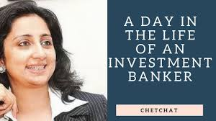

Picture from utube.com

How long is investment banking training?

I researched on news.efinancialcareers.com (June 15, 2016):

1. “The first few weeks of an **investment banking** analysts’ career are spent in the classroom.”
2. “There will be a corporate on-boarding process, regulatory **training** and exams if needed, but most importantly a technical **training** program that usually lasts two to four weeks.”



Picture from wellsfargo.com

Which are the best universities to attend college of finance in Atlanta and in Georgia?

To answer this question I researched on universities.com

“Best Finance Colleges in Atlanta for 2020

|  |  |  |
| --- | --- | --- |
| Rank | School Name | Rating |
| 1 | Georgia State University | Based on 32 Reviews |
| 2 | University of West Georgia | Based on 20 Reviews |
| 3 | Georgia Piedmont Technical College |  |
| 4 | Gwinnett Technical College.” |  |



Picture from noobpreneur.com

How much does an investment banker get paid in Atlanta?

According to glassdoor website:

“Average Base Pay of investment banker is:

$68,180/yr”



Picture from ondutymagazine.com



Rakhi Poonia is literacy secretary of Rajasthan Association of Atlanta 2020-21. She is a recipient of 2009 David Gould Scholarship sponsored by American Society for Public Administration. She is also a recipient of Pi Alpha Alpha (2006) for Public Service sponsored by Northern New Jersey chapter, USA.

She holds a Master’s in history from University of Delhi (India) and Master’s in Public Administration from University of Rajasthan, India.

Rakhi has also taught courses in Political Science at Rutgers the State University of New Jersey 2004-2008.

She has published more than 10 business books. She has also published 7 children’s books. Rakhi Poonia books are available on amazon.com. She lives in Atlanta, Georgia with her husband Engineer Anil Poonia and eight-year-old son Aaron Poonia. Aaron is an extraordinary child and a recipient of Star Galaxy award 2020 at Settles Bridge Elementary School. He always makes his parents proud.

Rakhi Poonia writes business books to generate employment among youth. To help small and medium sized businesses move forward and generate profits. To help those who want to dream big and work towards their goal. Every dream is achievable.

Rakhi Poonia writes children’s books because children are our future. Child is father of man. To make a child smile is the biggest wealth. Children are gift of god. The way a society treats its children speaks volumes about that society.

Books published by Rakhi Poonia on amazon.com.

Business books and children’s books.





























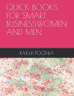













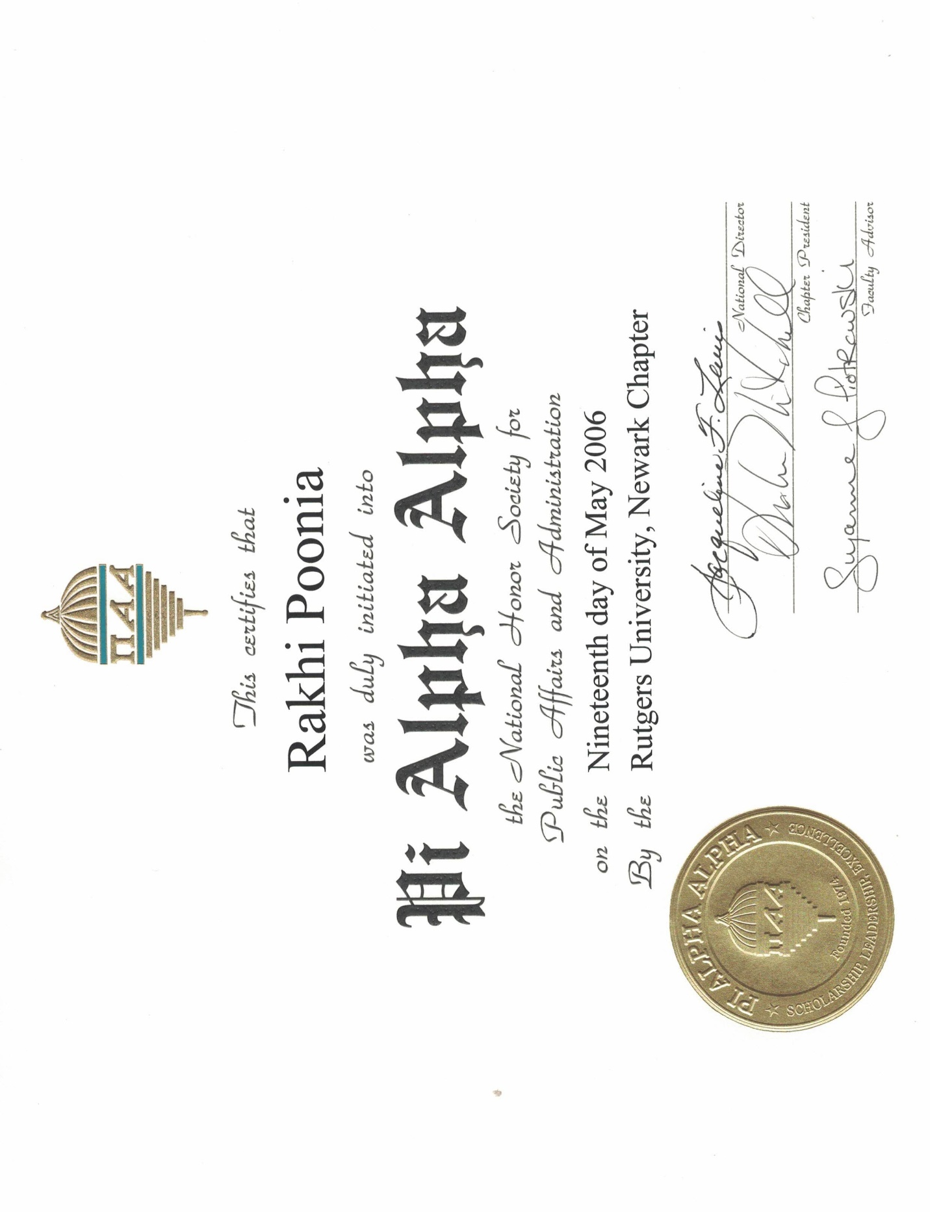



In god we trust.