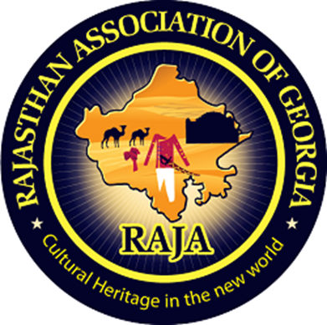

Rajasthan Association of Atlanta

Thirteenth Literacy Committee Newsletter

Literacy Secretary: Rakhi Poonia (2020-21).

How to become an architect in Atlanta and in Georgia?

Attitude of gratitude:

I’d first like to thank my nominators Sunil Mathur sir, Aashu Bhai Sahab, Brij sir, Dinesh Raj sir, Sudhir Agarwal sir, Sankalp Mathur DevDarshan sir, Pravin Soni sir, Praveen Gattani Sir, Ashok sir, Hari Mundhra sir, Dinesh Raj sir, and Anand Rathi sir for giving me the chance to help RAJA youth in capacity of its Literacy Secretary 2020-21.

Today’s newsletter required extensive as well as intensive research and analysis on my part.

I researched that being an architect in Atlanta and in Georgia is a white collar and high paying job.

Introduction

This newsletter answers questions like who is an architect? What are their job duties? How to become an architect in Atlanta and in Georgia? What are degree requirements of an architect in Atlanta and in Georgia? How much do they get paid?

Chapter 1

Who is an architect?

According to Wikipedia (2020):

1. “An architect is a person who plans, designs and oversees the construction of buildings.”
2. “To practice architecture means to provide services in connection with the design of buildings and the space within the site surrounding the buildings that have human occupancy or use as their principal purpose.”

Chapter 2

What are degree requirements of an architect in Atlanta and in Georgia?

1. According to [Wikipedia](https://en.wikipedia.org/wiki/Architect) (2020): “Entry level education of an architect in Atlanta is: Bachelor's degree.”
2. “Projected 10-year growth: 7% (2014).”
3. “Number of jobs: 112,600 (2014).”

According to www.architecturecareerguide.com:

1. “The licensing requirements for Georgia follow a more traditional approach of requiring a professional degree, completion of the Internship Development Program (IDP) and completion of the Architect Registration Exams (ARE).”



This picture is taken from architectmagazine.com

Chapter 3

Duties of an architect in Atlanta.

According to [www.linkedin.com](http://www.linkedin.com) architects in Atlanta perform several duties:

1. “They perform design/technical tasks and provide guidance to unlicensed staff regarding project production.”
2. “Develop construction documents.”
3. “Coordinate project documents and specifications.”
4. “Review drawings of junior team members to ensure building codes and regulatory requirements are met.”



I took this picture from atlantacurbed.com

Chapter 4

How much does an architect earn in Atlanta and in Georgia?

According to Glassdoor website:

1. “Architects in Atlanta, Georgia earn [$55k–100kper year.”](https://www.glassdoor.com/Salaries/atlanta-architect-salary-SRCH_IL.0,7_IM52_KO8,17.htm)

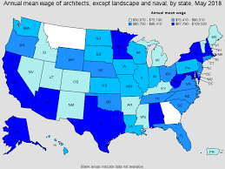

I took this picture from designerhacks.com

Chapter 5

Pictures of offices of architects in Atlanta and in Georgia?



I took this picture from Atlantaarchitects.org



I retrieved this picture from atlantaarchitects.org



I took this picture from www.danielanderson.wordpress.com



I took this picture of an architect from cbrandoningram.com

Conclusion:

Being an architect is a high paying and white-collar job in Atlanta and in Georgia.

This newsletter will help those RAJA youth who want to become an architect in Atlanta and in Georgia.

About RAJA literacy secretary Rakhi Poonia 2020-21

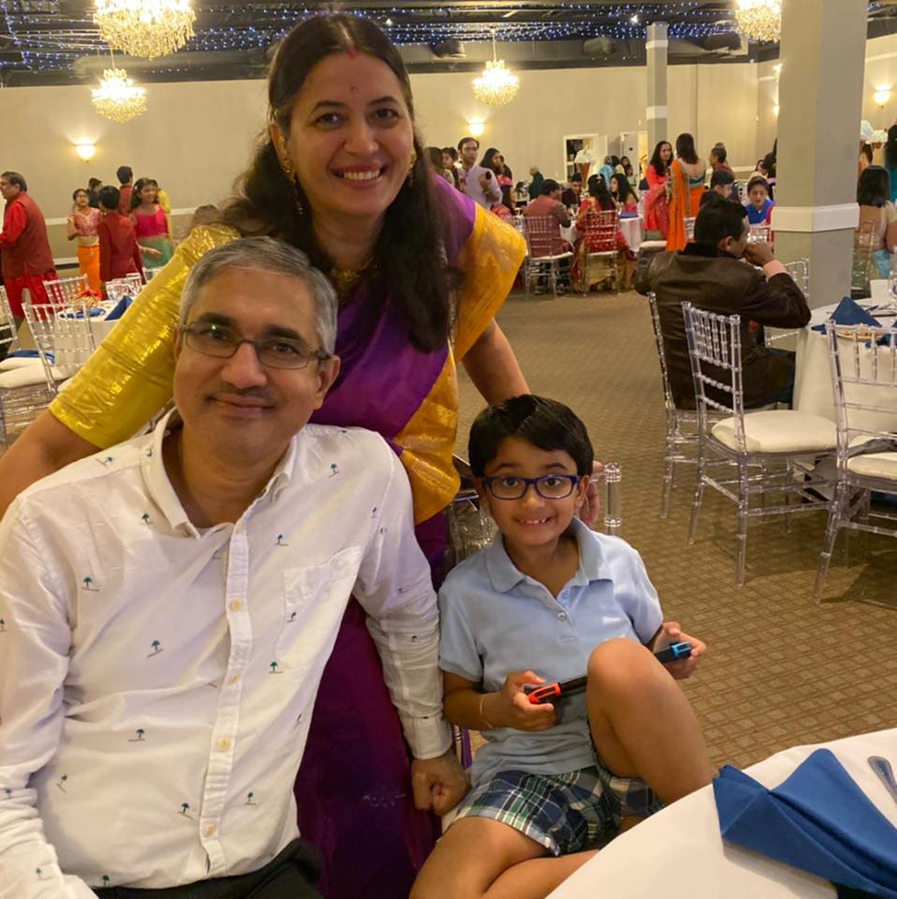

Rakhi Poonia is literacy secretary of Rajasthan Association of Georgia 2020-21. She is a recipient of 2009 David Gould Scholarship sponsored by American Society for Public Administration. She is also a recipient of Pi Alpha Alpha (2006) for Public Service sponsored by Northern New Jersey chapter, USA.

She holds a Master’s in history from University of Delhi (India) and Master’s in Public Administration from University of Rajasthan, India.

Rakhi has also taught courses in Political Science at Rutgers the State University of New Jersey 2004-2008.

Rakhi Poonia is recipient of several awards in USA like Pi Alpha Alpha Honor for Public Service (2006) and David Gould Scholarship sponsored by American Society for Public Administration (2009).

She has published more than 31 books on amazon.com as literacy secretary of RAJA. Her books cover a variety of subjects like business, children’s books, public service books, and education books. Rakhi Poonia books are available on amazon.com.

She lives in Atlanta, Georgia with her husband Engineer Anil Poonia and eight-year-old son Aaron Poonia. Aaron is an extraordinary child and a recipient of Star Galaxy award 2020 at Settles Bridge Elementary School. He always makes his parents proud.

Rakhi Poonia writes business books as literacy secretary of RAJA to generate employment among youth. To build human resource capital. To help small and medium sized businesses move forward and generate profits. To help those who want to dream big and work towards their goal. Every dream is achievable.

Rakhi Poonia writes children’s books because children are our future. Child is father of man. To make a child smile is the biggest wealth. Children are gift of god. The way a society treats its children speaks volumes about that society.

Rakhi Poonia writes public service books to instill value of public service amongst RAJA youth.

Rakhi Poonia writes education books to help RAJA youth attain their education goals.

Books published by Rakhi Poonia are available on amazon.com.

Rakhi Poonia has written business books, children’s books, public service books, and education books with the intention of helping RAJA youth move forward and excel in their lives. She has written these books in capacity of RAJA literacy secretary 2020-21 for RAJA .

Rakhi Poonia books on amazon.com

Education book 1



Education book 2

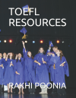

Public service book 1

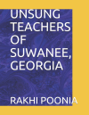

Public service book 2

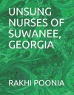

Public service book 3



Public service book 4



Rest of books…







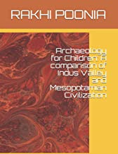

(New!)











































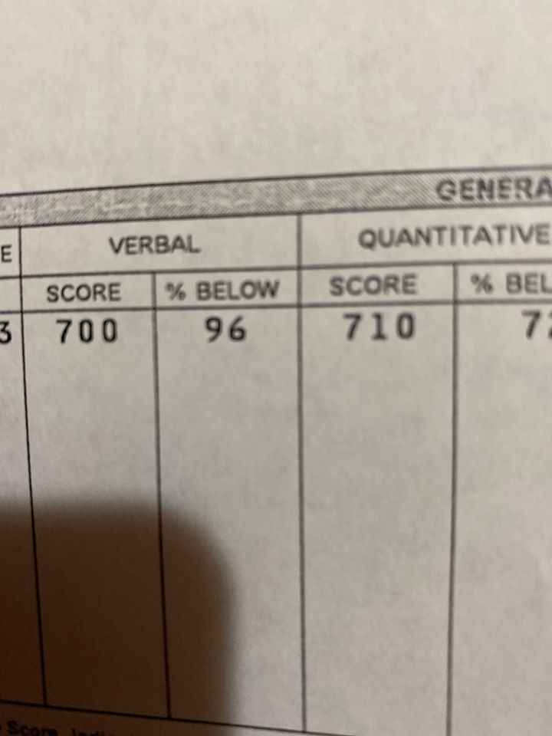

Rakhi Poonia is a recipient of percentile 96 in GRE test verbal section USA after having studied 3,800 words in English, 13 GRE books, and every test on ETS website.

Hence, she has written her most recent book GRE RESOURCES on amazon.com to help RAJA youth get admission in their dream University in Atlanta and in Georgia with full financial aid. This book is available on amazon.com now.

Education today means better life tomorrow.



Image of laxmi ganesh from flikart website.